## 

**GiftEase – Smart Gift Card Transaction Platform**

Brahmaiah Boyalla

A Project Submitted to

GRAND VALLEY STATE UNIVERSITY

In

Partial Fulfillment of the Requirements

For the Degree of

Master of Science in Applied Computer Science

School of Computing

April 2025



The signatures of the individuals below indicate that they have read and approved the project of **Brahmaiah Boyalla** in partial fulfillment of the requirements for the degree of Master of Science in Applied Computer Science.

______________________________________________________

Yong Zhuang, Project Advisor Date

______________________________________________________

Robert Adams, Graduate Program Director Date  
______________________________________________________  
Dr. Marouane Kessentini, Unit head Date

# Abstract

GiftEase addresses a common frustration in the modern digital economy: the difficulty of exchanging, verifying, and reselling unused gift cards. Despite their widespread use for rewards, gifts, and promotions, users often face issues related to fraud, limited resale avenues, and lack of transparency. This project presents GiftEase, a secure and user-friendly platform built with Django and integrated with modern web technologies like HTML, Tailwind CSS, and Stripe for payment handling. The application facilitates smooth transactions for buying and selling gift cards from brands like Amazon, Flipkart, and Myntra. Security features such as CSRF protection and session-based authentication safeguard transactions, while SMTP integration ensures timely email delivery of cards. GiftEase demonstrates a practical application of full-stack development concepts, aligning with industry standards in security, scalability, and user experience. It consolidates various gift card functionalities into a single marketplace, empowering users with transparency, safety, and ease of use. Future iterations will introduce mobile support, AI-based fraud detection, and advanced verification systems to further improve platform reliability and reach.

# Introduction

Gift cards have become a popular alternative to cash, especially in online retail ecosystems. However, the lack of a centralized and trustworthy system for managing gift cards creates barriers for both buyers and sellers. GiftEase was conceptualized to bridge this gap through a reliable, secure, and intuitive marketplace that simplifies transactions involving gift cards. The project combines technical knowledge acquired during the Master’s program with new skills in user experience design, payment gateway integration, and backend development using Django. The platform not only streamlines the process of gift card exchange and verification but also promotes safe transactions through built-in security mechanisms. The primary goal was to create a single hub where users can manage all aspects of gift card transactions, including listing, purchasing, and receiving gift cards digitally. The project is significant because it reduces fraud, boosts user confidence, and creates a scalable model for gift card resale.

**Organization**

The application was designed as a full-stack web application. The frontend is built using HTML and Tailwind CSS with Material UI for styling consistency. The backend is developed using Django, with SQLite3 as the initial database. The architecture includes a layered structure consisting of presentation (frontend), business logic (Django views and models), and data layers (SQLite). Authentication is handled using Django’s built-in session management. Stripe is integrated to process payments, and SMTP is used for email delivery of purchased gift cards. Users can register, list cards for sale, filter and buy cards, and track transactions securely.

**Results/Implementation**

GiftEase was successfully implemented as a full-stack platform enabling secure gift card transactions. Key features include user registration, gift card listing, real-time search and filtering, Stripe-based payment, and email delivery via SMTP. The UI is responsive and built using Tailwind CSS and Material UI for consistent styling. Users can manage cards, track orders, and update profiles seamlessly. Figures 1–8 below illustrate the core functionality and interface of the application.

***Figure 1: LOGIN PAGE***

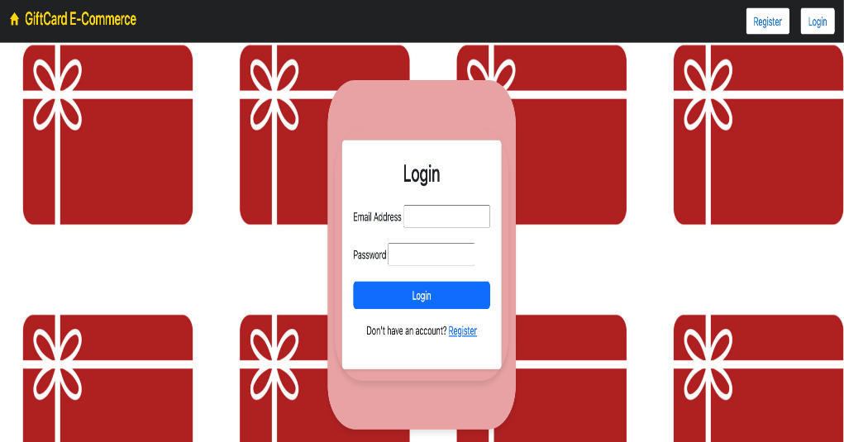

***Figure 2: REGISTRATION PAGE***

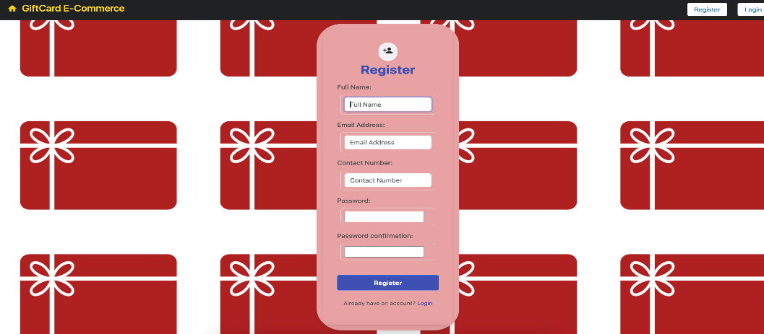

***Figure 3: HOME PAGE***

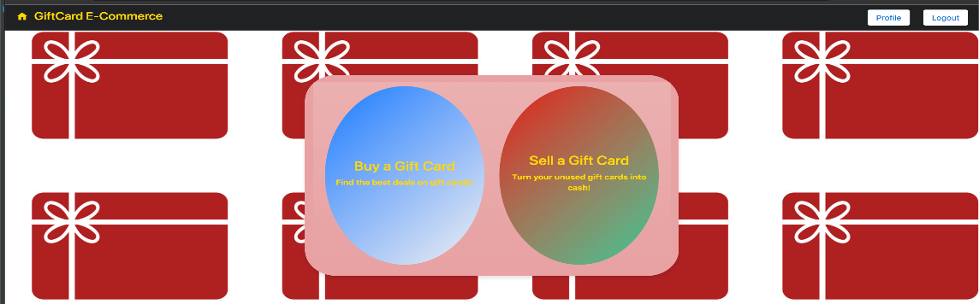

**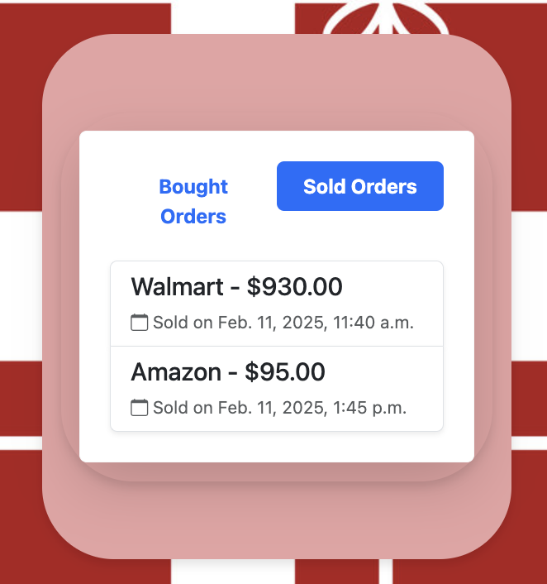*Figure 4: ORDERS PAGE***

**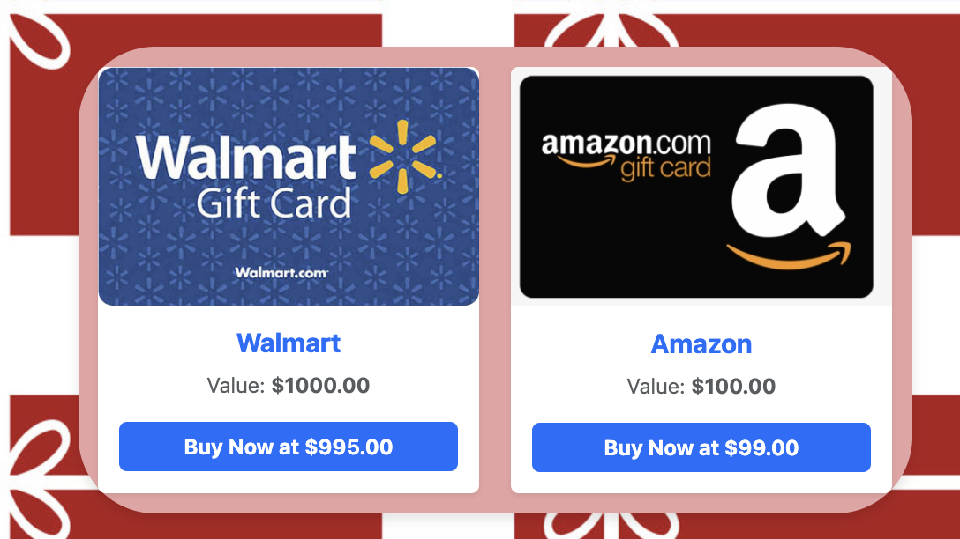*Figure 5: GIFT CARDS LISTING PAGE***

# *Figure 6: GIFT CARD SELLING PAGE* *Figure 7: PAYMENTS PAGE*

**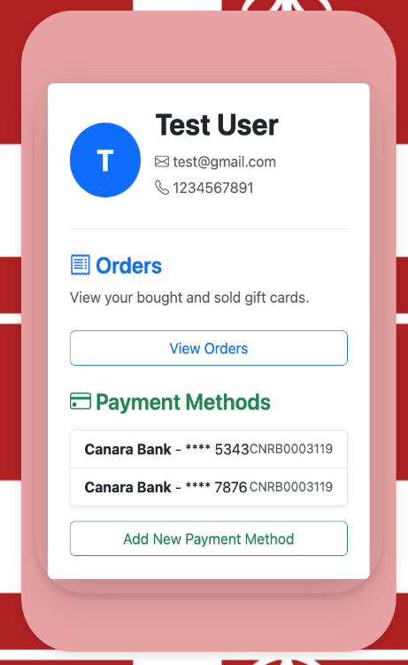*Figure 8: PROFILE PAGE***

# Conclusions

The GiftEase platform successfully addresses users' challenges when managing gift cards, such as a lack of trust, limited resale options, and security concerns. By combining robust backend services with a responsive frontend interface, the project delivers a seamless experience for buying, selling, and receiving gift cards. The integration of Django authentication, Stripe payments, and SMTP email services ensures security, reliability, and ease of use. Overall, the project meets its objectives by offering a centralized, transparent, and user-friendly solution for gift card transactions.

**Future Work:**

To expand the platform’s capabilities and user base, the following features are planned:

* Implement an advanced gift card authenticity verification system.
* Add a digital wallet to store and manage gift cards.
* Track partially used cards with updated balances.
* Introduce buyer/seller ratings and reviews for trust-building.
* Develop a mobile application for broader accessibility.
* Launch referral and loyalty programs to boost engagement.
* Support alternative payment methods like cryptocurrencies.
* Integrate AI-based fraud detection mechanisms.
* Enable multilingual support for global users.

# Bibliography

1. Amazon Gift Card Official Website: <https://www.amazon.in/gift-card>
2. Flipkart Gift Card Information: <https://www.flipkart.com/the-gift-card-store>
3. Myntra Gift Card Store: <https://www.myntra.com/giftcard>
4. Razorpay Payment Gateway Documentation: <https://razorpay.com/docs/>
5. PayPal Developer Guide: https://developer.paypal.com/home/
6. Django Documentation: <https://docs.djangoproject.com>
7. React.js Documentation: <https://react.dev/>

**Appendices**

**Code Repository:** <https://github.com/Brahmiboyalla/GiftEase>